Data Transformation

🧾 What Is Data Transformation?
# Source: AI Source: Provided by: [Data Path: Persons Table -> ID Column: 1, Name_En Column: Motasem Essam] -> From: [ChatGPT] on [2/12/2026]
Data transformation is the process of converting data from one format, structure, or value into another so it can be used effectively.
👉 It prepares data for processing, storage, or display.

✅ Simple Definition:
# Source: AI Source: Provided by: [Data Path: Persons Table -> ID Column: 1, Name_En Column: Motasem Essam] -> From: [ChatGPT] on [2/12/2026]
Data transformation is changing data into a suitable form for use in the system.

🧠 Real-Life Analogy:
# Source: AI Source: Provided by: [Data Path: Persons Table -> ID Column: 1, Name_En Column: Motasem Essam] -> From: [ChatGPT] on [2/12/2026]
Think of it like currency exchange 💱:
● You have USD
● You convert it to EUR
👉 Same value, different format

🔁 How Data Transformation Works
# Source: AI Source: Provided by: [Data Path: Persons Table -> ID Column: 1, Name_En Column: Motasem Essam] -> From: [ChatGPT] on [2/12/2026]
- 👤 User or system provides data
- 📥 Data is received
- 🔄 Data is converted or formatted
- ✅ Transformed data is used or stored

📊 Types of Data Transformation

🔹 1. Format Transformation
# Source: AI Source: Provided by: [Data Path: Persons Table -> ID Column: 1, Name_En Column: Motasem Essam] -> From: [ChatGPT] on [2/12/2026]
Change data format
👉 Example:
- String → JSON
- Date → standard format

🔹 2. Data Mapping
# Source: AI Source: Provided by: [Data Path: Persons Table -> ID Column: 1, Name_En Column: Motasem Essam] -> From: [ChatGPT] on [2/12/2026]
Rename or map fields
👉 Example:
- fname → first_name

🔹 3. Data Conversion
# Source: AI Source: Provided by: [Data Path: Persons Table -> ID Column: 1, Name_En Column: Motasem Essam] -> From: [ChatGPT] on [2/12/2026]
Change data type
👉 Example:
- "25" (string) → 25 (integer)

🔹 4. Data Normalization
# Source: AI Source: Provided by: [Data Path: Persons Table -> ID Column: 1, Name_En Column: Motasem Essam] -> From: [ChatGPT] on [2/12/2026]
Standardize values
👉 Example:
- "USA", "U.S.A" → "United States"

🔹 5. Data Aggregation
# Source: AI Source: Provided by: [Data Path: Persons Table -> ID Column: 1, Name_En Column: Motasem Essam] -> From: [ChatGPT] on [2/12/2026]
Combine data
👉 Example:
- Total price = sum of items

💻 Simple PHP Example
# Source: AI Source: Provided by: [Data Path: Persons Table -> ID Column: 1, Name_En Column: Motasem Essam] -> From: [ChatGPT] on [2/12/2026]
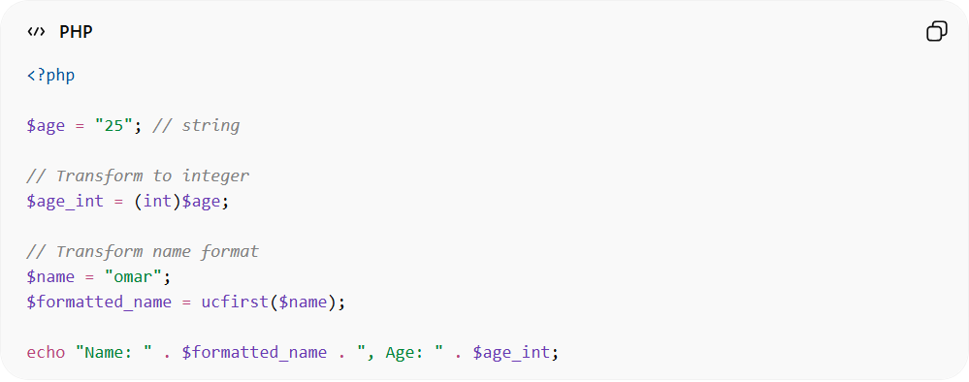
<?php

$age = "25"; // string

// Transform to integer
$age_int = (int)$age;

// Transform name format
$name = "omar";
$formatted_name = ucfirst($name);

echo "Name: " . $formatted_name . ", Age: " . $age_int;
● Converts string to integer
● Formats text (capitalization)
● Makes data usable

📦 Example (Before vs After)
# Source: AI Source: Provided by: [Data Path: Persons Table -> ID Column: 1, Name_En Column: Motasem Essam] -> From: [ChatGPT] on [2/12/2026]
Before:
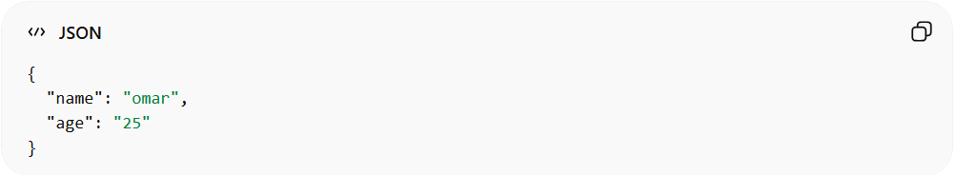
{
"name": "omar",
"age": "25"
}
After:
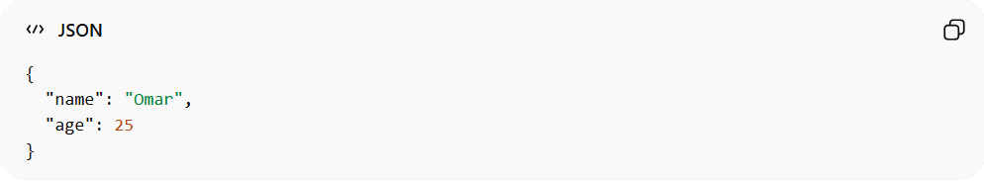
{
"name": "Omar",
"age": 25
}
👉 Data becomes clean and consistent

⚠️ Why Transformation Is Important
# Source: AI Source: Provided by: [Data Path: Persons Table -> ID Column: 1, Name_En Column: Motasem Essam] -> From: [ChatGPT] on [2/12/2026]
Without transformation:
❌ Inconsistent data
❌ Hard to process
❌ Errors in system
👉 Transformation makes data usable

🔗 Relation to Other Topics
# Source: AI Source: Provided by: [Data Path: Persons Table -> ID Column: 1, Name_En Column: Motasem Essam] -> From: [ChatGPT] on [2/12/2026]
● Input Handling → receives data
● Validation → checks data
● Sanitization → cleans data
● Transformation → converts data
👉 All steps work together

⚙️ Best Practices
# Source: AI Source: Provided by: [Data Path: Persons Table -> ID Column: 1, Name_En Column: Motasem Essam] -> From: [ChatGPT] on [2/12/2026]
✅ Keep data consistent
✅ Use proper data types
✅ Standardize formats (dates, names)
✅ Transform before storing

🎯 Key Idea
# Source: AI Source: Provided by: [Data Path: Persons Table -> ID Column: 1, Name_En Column: Motasem Essam] -> From: [ChatGPT] on [2/12/2026]
👉 Transformation = change data format or structure
👉 Makes data ready for use

🎓 Final Mental Model
# Source: AI Source: Provided by: [Data Path: Persons Table -> ID Column: 1, Name_En Column: Motasem Essam] -> From: [ChatGPT] on [2/12/2026]
● Input → raw data
● Validation → check
● Sanitization → clean
● Transformation → convert
👉 Final result = usable data ✅

